Student Name: Azamat Salamatov

Professor Cleveland

COMP 3324 - 1

Week 4 – Lab 1- Using Burp Suite to Penetrate to the Web Apps

February 28, 2023,

Burp to penetration testing of web applications

Contents

Intercepting a Plaintext Search 1

My summary on this project 3a: 2

Intercepting an Encrypted Login 3

My summary on this project 3b: 4

Using Burp Site Map 5

My summary on Project 3c: 5

# Intercepting a Plaintext Search

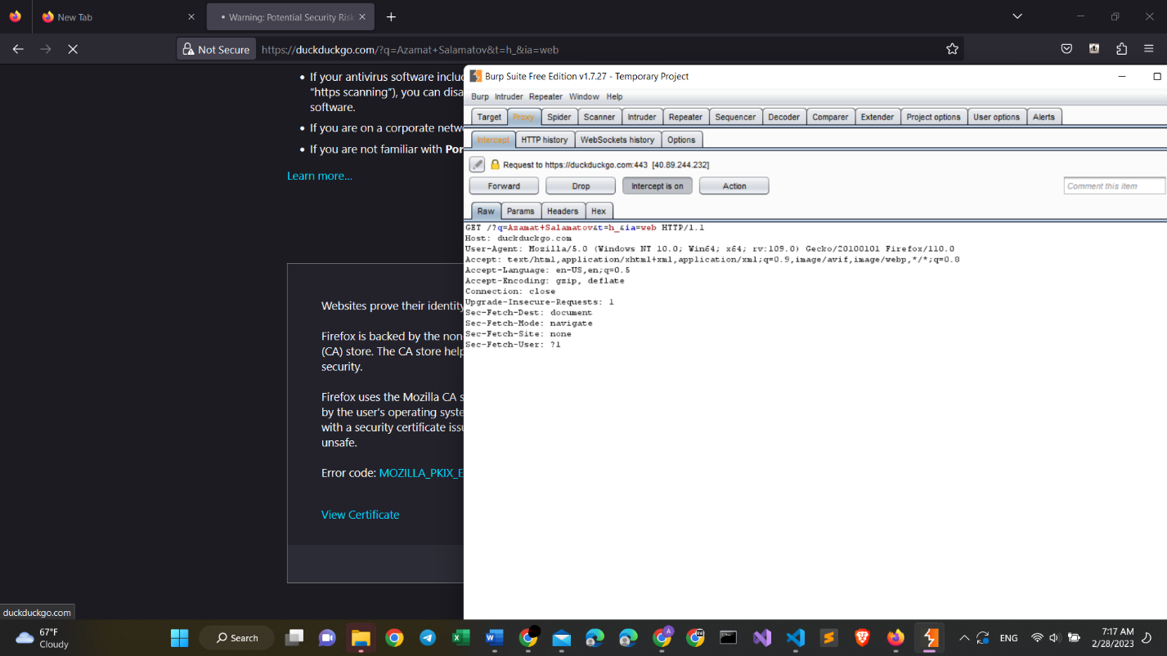

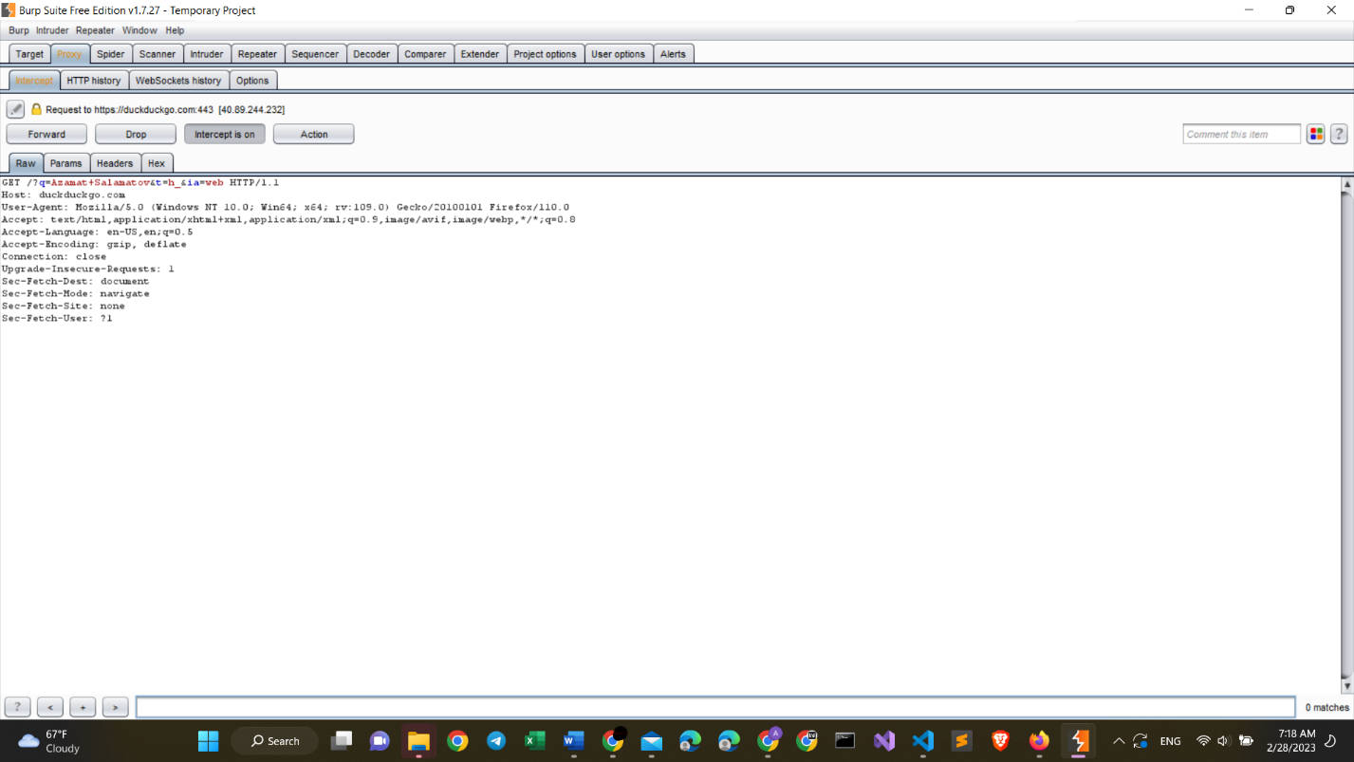

*Project 3a from Azamat Salamatov*

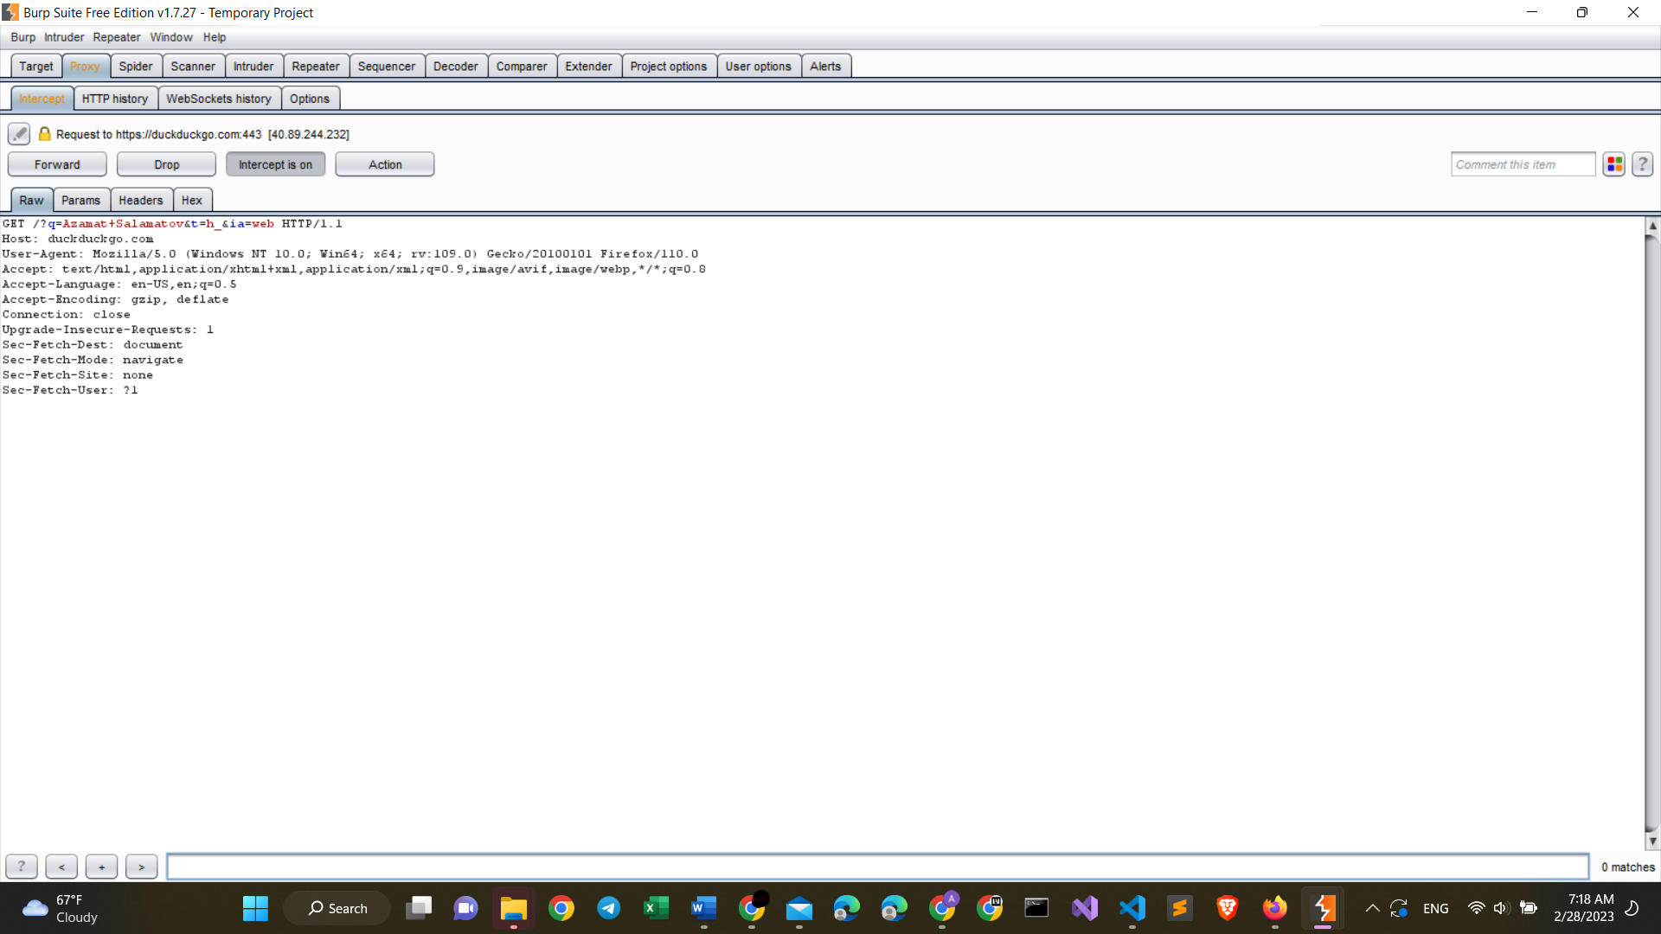

*Project 3a from Azamat Salamatov (zoomed in)*

# My summary on this project 3a:

* I have tried many times to use bing.com search engine. However, it did not allow me to add burp as an exception for penetrating. That’s why I used DuckDuckGo search engine instead. As it is seen from the image above, it worked pretty well.
* Using burp’s last version also did not allow me to use it efficiently, as it is instructed in the lab requirements. That is why I used Burp Suite Free Edition Version 1.7.27. It allowed me to get full functionality.
* While doing this assignment, I understood, that these applications update over time, and some techniques are not used anymore. That is the reason to always hone our skills, and study even after we graduate. Technology is changing very quickly. And we need to stay up-to-date.

# Intercepting an Encrypted Login

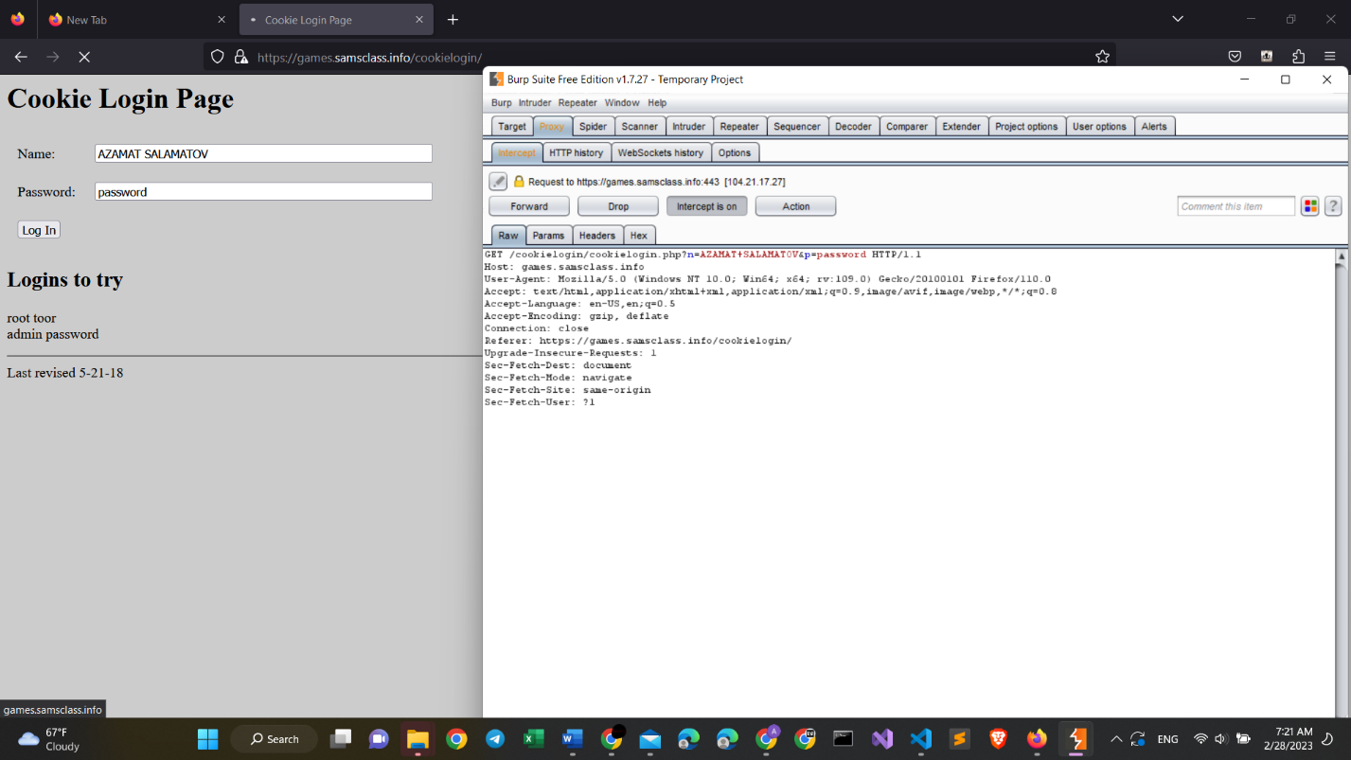

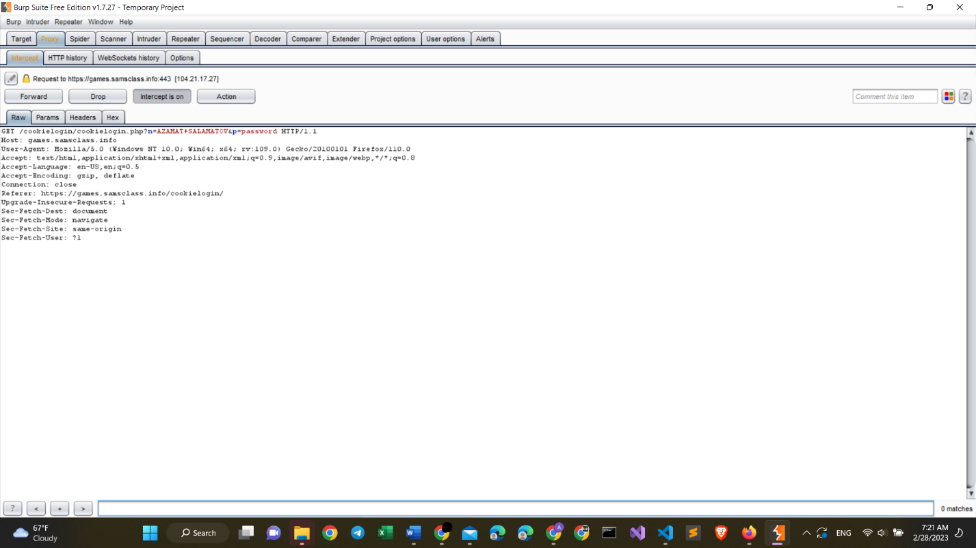

*Project 3b from Azamat Salamatov*

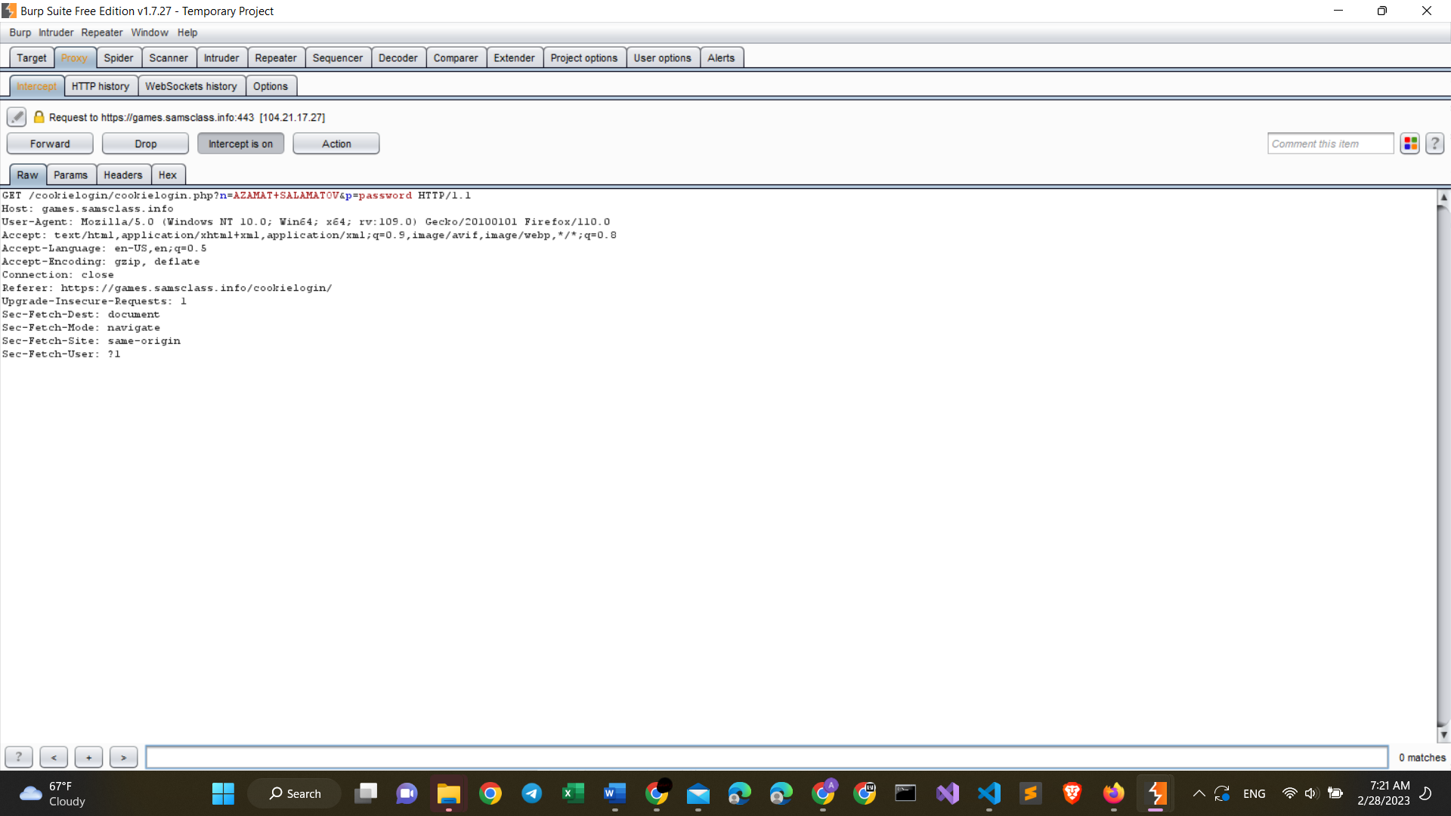

*Project 3b from Azamat Salamatov (zoomed in)*

# My summary on this project 3b:

* This project worked without any problems, because I already understood the settings and basic functionality of Burp Suite and Firefox browser.
* This project shows, that if we do not pay attention to the security of our websites, our data can easily be transmitted to other people. The security problem here was that we added Burp as a security exception. In future, we need to be very careful before giving access to a third-party software like Burp or any other.

# Using Burp Site Map

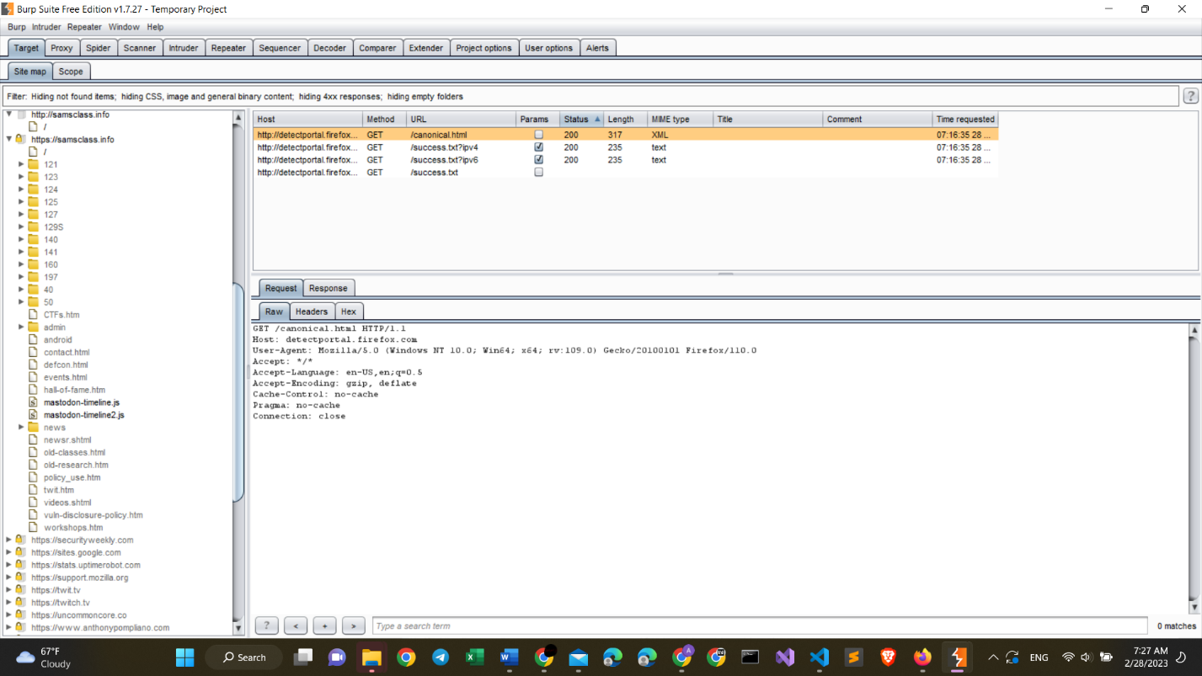

*Project 3c from Azamat Salamatov*

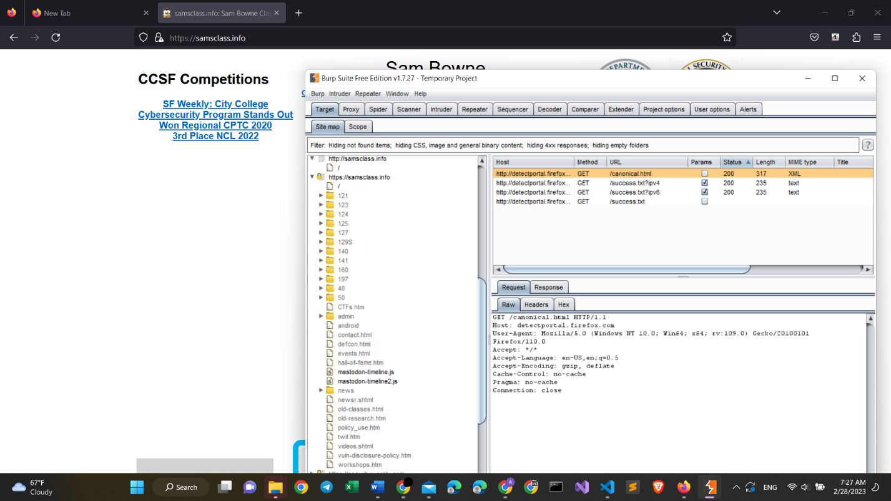

*Project 3c from Azamat Salamatov (both the site and Burp view)*

# My summary on Project 3c:

* This project also worked pretty well. However, I encountered some issues when trying to add a security exception of Burp. Because of the new update of Firefox it is hard to add a new exception when using a secured website, starting with **HTTPS://,** however, when I deleted the https://, it worked pretty fine.
* This project showed me that sites can also be viewed by third-party sides. But our browser always wants to secure us. The reason why Burp worked, is that I consciously allowed burp to hack my browser. In future, we must be a lot careful, when giving access to an unknown sides, apps, or websited.